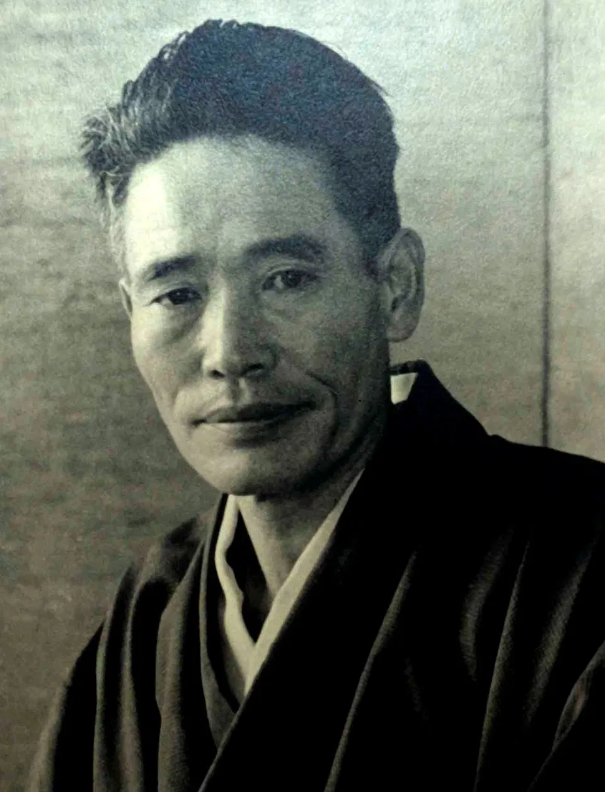
Chiura Obata
(1885-1975)

Teacher Packet
©️2020

Table of Contents

Biography - Chuira Obata 3
Lesson 1 : Obata Inspired Landscape Art (grades K -12) 4
Lesson 2 : Obata-Inspired Poetry (grades 2 - 7) 7
Lesson 3 : Environmentalism “Can Art Save the World?” (grades 4-8) 10
Lesson 4 : 1906 San Francisco Earthquake (grades 4 and above) 14
Lesson 5 : Japanese Incarceration Experience and Political Art (grades 6-12) 18
Resources 23

Biography - Chuira Obata
Chiura Obata (1885-1975) was a renowned landscape artist, professor, and devoted environmentalist. Born 1885, in Japan, Obata studied ink painting before immigrating to California in 1903. After settling in Japantown in San Francisco, Obata established himself as an artist and took on large-scale commissioned art projects. After an influential trip to Yosemite in 1928, Obata began devoting his art to portraying landscapes and the beauty of nature. Throughout the next decade, Obata continued to earn recognition, but like many Japanese Americans during WWII, his life was violently uprooted as his family was interned, first at Tanforan and then at Topaz. During his imprisonment, Obata was able to start art schools at both camps, teaching hundreds of students and even holding an exhibition in 1942. After the end of the war, Obata returned to lecture at UC Berkeley, joined the Sierra Club’s environmentalist efforts, and consistently celebrated Japanese aesthetics until his death. Over the course of a seven-decade career, Obata became a prominent educator at UC Berkeley and a central leader in the California Art scene.

This teacher packet contains the following lesson plans :
- Create an Obata-Inspired Landscape Painting
- Obata-Inspired Poetry
- Save the National Parks Environmentalism through Art
- Exploring the 1906 Earthquake through Primary Source Documents
- WWII Japanese Internment and Political Art

Keywords/Object of Study
Environmentalism; Woodblock Prints; Landscape Artist ; Asian American Artists; Japanese American Artists; Japanese Internment Experience; Early California History 20th c.; San Francisco Art History; National Parks; Nature inspired Art; Environmentalist Art; Political Art

Links to Virtual Art Archives
- https://americanart.si.edu/search?query=%22Chiura%20Obata%22&f%5B0%5D=content_type%3Aartwork&page=0
- https://americanart.si.edu/exhibitions/obata
- Asian Art Museum Collection Search

Lesson 1 : Obata Inspired Landscape Art (grades K -12)

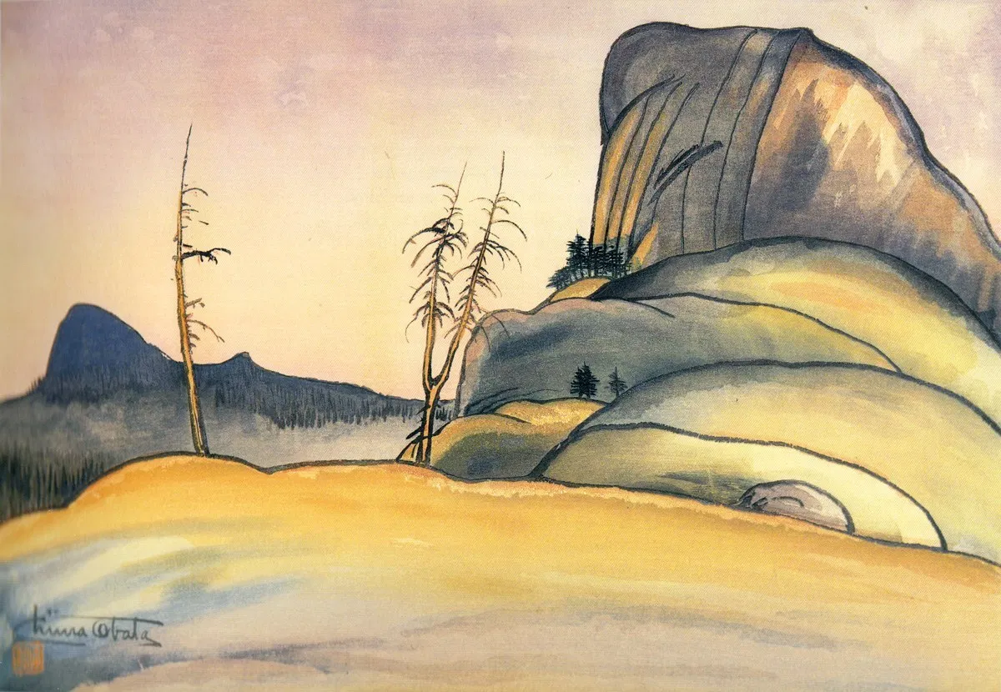
Death’s Grave Pass, 1930, color woodblock print

Student Outcome : Students will study Obata’s signature landscape paintings and create individual works of art in his style, using texture from nature. Students will further compare and contrast patterns, color, and texture between their work and Obata’s.

Common Core Content Standards

K.VA:Re8 - 7.VA:Re8 Interpret art by analyzing art-making approaches, the characteristics of form and structure, relevant contextual information, subject matter, and use of media to identify ideas and mood conveyed.
K.VA:Re8 Interpret art by identifying subject matter and describing relevant details.
1.VA:Re7.2 Compare images that represent the same subject.
2.VA:Re8 Interpret art by identifying the mood suggested by a work of art and describing relevant subject matter and characteristics of form.
3.VA:Re8 Interpret art by analyzing use of media to create subject matter, characteristics of form, and mood.
5.VA:Cr2.3 Identify, describe, and visually document places and/or objects of personal significance.

K.MA:Cr1 Discover and share ideas for media artworks using play and/or experimentation.
1.MA:Cr3 a. Create, capture, and assemble media arts content for media arts productions, identifying basic aesthetic principles, such as pattern and repetition. Practice and identify the effects of making changes to the content, form, or presentation, in order to refine and complete media artworks.
6.MA:Cr3 Experiment with multiple approaches to produce content and components for determined purpose and meaning in media arts productions, utilizing a range of associated aesthetic principles, such as point of view and perspective.
Appraise how elements and components can be altered for intentional effects and audience, and refine media artworks to reflect purpose and audience.

Materials
Tempera Paint or Watercolor
Paper
Paint Brushes
Black Pens
Materials from nature - rocks, acorns, leaves, wood chips to be used as texture
Obata’s art prints - Artworks Powerpoint - Landscape Art or can be found in the virtual archive links above

Procedure
Introduction
- Begin by introducing Obata’s artwork and life story to students.Practice close looking at Obata’s signature landscape paintings. Use questions to direct conversation, such as the following:
  - What colors do you notice? Are the colors bright or darker? What textures do you see? What lines or patterns do you notice? What are some things that you see in each painting, what is Obata painting in each of his artworks?
- Make images visible either electronically or by physically distributing printouts to table groups.
- Ask students to brainstorm what they will create.
  - Allow students to decide what landscape they will be painting (lake, trees, flowers, fields, mountains?)
  - Ask students to decide what time of day and season will be represented in their paintings.
- Do a demonstration to show students how to begin their artworks.
- Do another demonstration on how to incorporate texture. Gently paint a leaf, piece of wood, rock, acorn, etc, and stamp on the page. Use multiple stamps to create a larger pattern.
- Get creative!
Art Project
- Distribute practice materials to students : scratch paper to begin and natural objects for texture.
- Provide time to sketch landscapes and practice texture before beginning the final project.
- Distribute final materials (paper, paint, black pens) once class is ready.
- Use a pencil or Sharpie pen to create outlines, before using paint.
- Add texture throughout student art pieces.

Discussion
- Ask students to describe what their favorite Obata artwork is. Were they inspired to use any of his techniques in their painting?
- Why do they think Obata painted so frequently?

Extensions
- Consider adding shading to your discussion and demonstration of art techniques.
- Consider exploring An Introduction to Chinese Brush Painting, and discussing East Asia Ink techniques in relation to your project and to Obata’s sumi ink work.

Lesson 2 : Obata-Inspired Poetry (grades 2 - 7)
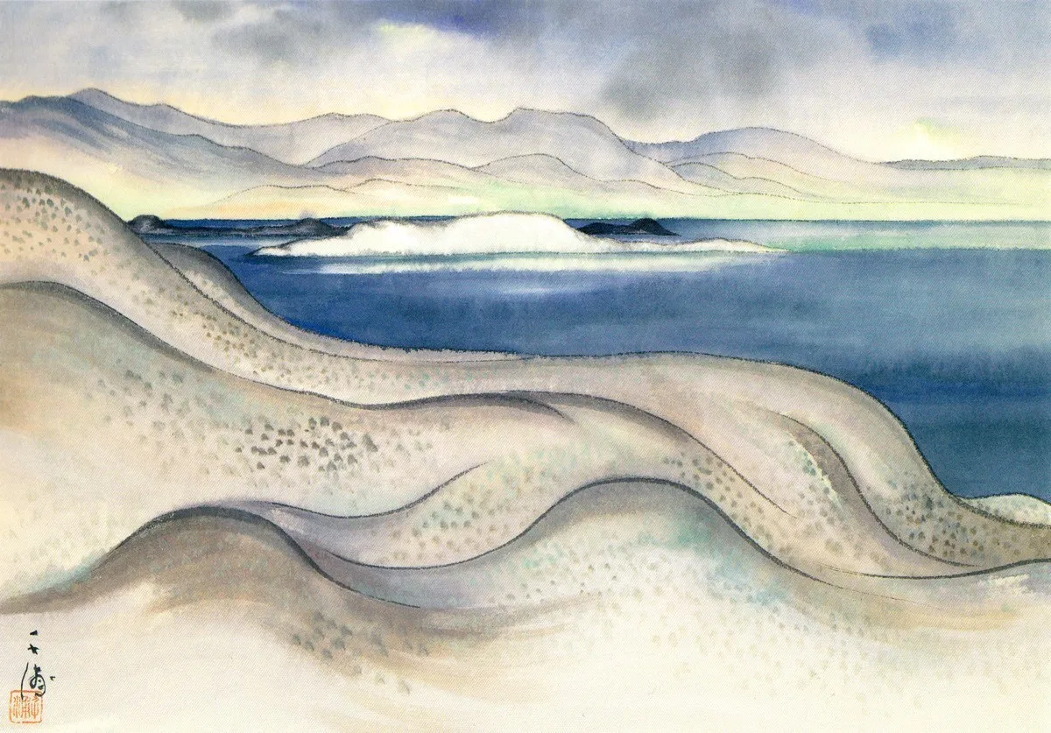
Along Mono Lake, 1927, sumi and watercolor on paper

Student Outcome : Students will practice close looking and writing skills through crafting poems inspired by Obata’s natural landscapes.

Common Core Standards

RL.1.4 Identify words and phrases in stories or poems that suggest feelings or appeal to the senses.
SL.2.5 Add drawings or other visual displays to stories or recounts of experiences when appropriate to clarify ideas, thoughts, and feelings.
SL.3.5 Create engaging audio recordings of stories or poems that demonstrate fluid reading at an understandable pace; add visual displays when appropriate to emphasize or enhance certain facts or details.
RI.3.7 Use information gained from illustrations (e.g., maps, photographs) and the words in a text to demonstrate understanding of the text (e.g., where, when, why, and how key events occur).
RL.3.10 By the end of the year, read and comprehend literature, including stories, dramas, and poetry, at the high end of the grades 2–3 text complexity band independently and proficiently.
W.6-7.3.d Use precise words and phrases, relevant descriptive details, and sensory language to convey experiences and events.
RL.7.10 By the end of the year, read and comprehend literature, including stories, dramas, and poems, in the grades 6–8 text complexity band proficiently, with scaffolding as needed at the high end of the range.

Materials
Collection of Obata’s artworks (Can be found in Artworks Powerpoint - Landscape Art PowerPoint or in the virtual archives linked above)
(Optional) Obata’s Yosemite : Art and Letters of Obata from His Trip to the High Sierra in 1927
Paper
Pencils
Colored Pencils
Paint (to decorate)

Procedure
- Introduce Chiura Obata. Consider how nature-inspired artwork has influenced society through a classroom discussion.
  - Lead a discussion on how and why it is important to celebrate nature. Ask questions such as :
    - How is nature important?
    - How can we preserve nature?
    - Why is it important for people to celebrate nature?
- Show students the following poem by Obata along with an artwork ; invite a classroom reader to read aloud the text.
My aim is to create a bowl full of joy
Clear as the sky,
Pure as falling cherry petals,
Without worry, without doubt;
Then comes full energy, endless power
And the road to art.
- Ask students to consider what these words mean. Ask students how the placement of words on the page changes how we view the poem.
- Inform students of the following assignment : Students will compose rough drafts of poems inspired by landscape art. Poems should be 6-12 lines long, using both a metaphor and simile. Define metaphor and simile for your students, if you have not covered this material previously.
  - Metaphor — A figure of speech that is used to make a comparison between two things that aren't alike but do have something in common
https://examples.yourdictionary.com/metaphor-examples-for-kids.html
  - Simile — a figure of speech that directly compares two different things. The simile is usually in a phrase that begins with the words "as" or "like." This is different from a metaphor, which is also a comparison but a metaphor says something is something else.
https://examples.yourdictionary.com/simile-examples-for-kids.html
- Distribute art prints or show the Artworks Powerpoint - Landscape Art for students to view; allowing for brainstorming time for students to consider the subject of their poems.
- Allow time to write poems on art paper, trace poems with sharpie, and decorate to display.

Extensions
- Extend or modify the assignment for the following themes : saving nature, visiting a national park, or simply an experience that students have had outside.
- Consider incorporating the effect ofClimate Change's effect on Nature in your discussion and poem prompt.

Lesson 3 : Environmentalism “Can Art Save the World?” (grades 4-8)
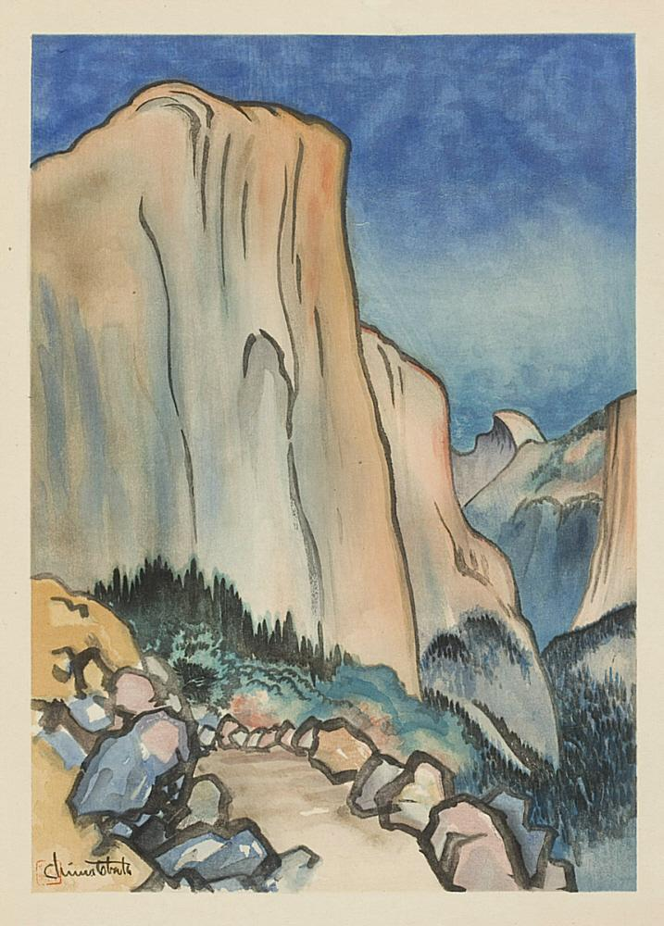
Capitan: Yosemite National Park, 1930年, Chiura Obata (b. Japanese, 1885 - 1975), Woodblock Print, Asian Art Museum, Gift of Dr. Stephen A. Sherwin and Merrill Randol Sherwin, 2010.13, Photograph © Asian Art Museum

“Obata spent the summer of 1927 visiting Yosemite with the artists Worth Ryder (1884–1960) and Robert Boardman Howard (1896–1983). This view of El Capitan was based on one of the watercolor sketches Obata made during their stay. Obata rendered the dramatic scenery of Yosemite through simplified, almost abstract forms. He used watercolor tones to define the elements of the scene and to give the sky its lush color, but ink— as in traditional Japanese painting—to describe the landscape's textures: long, smooth strokes for the granite wall, wide and angular strokes for knobby foreground boulders, and dots, scalloped patterns and longer strokes to represent the valley's evergreen trees.”
Source : Asian Art Museum http://searchcollection.asianart.org/view/objects/asitem/id/37693

Student Outcome : Students will consider the ways art can be used as activism in the context of Environmentalism and National Park Preservation.

Grade Levels : This lesson is designed for upper elementary, middle school and high school students with appropriate modifications.
Duration : Two class periods, with an optional take home assignment.

Common Core Standards
ESS3.C Human activities in agriculture, industry, and everyday life have had major effects on the land, vegetation, streams, ocean, air, and even outer space. But individuals and communities are doing things to help protect Earth’s resources and environments.

Visual Arts
Visual Arts 3.0 Understanding the Historical Contributions and Cultural Dimensions of the
4.VA:Re7.2 Interpret art by analyzing use of media to create subject matter, characteristics of form, and mood.
Visual Arts 5.0 Connecting and Applying What is Learned in the Visual Arts to Other Art Forms
and Subject Area and to Careers
5.VA:Cn11 Identify how art is used to inform or change beliefs, values, or behaviors of an individual or society.
6.VA:Re7.2 Analyze ways that visual components and cultural associations suggested by images influence ideas, emotions, and actions.

Media Arts
6.MA:Cn11 Discover and share ideas for media artworks using play and/or experimentation.
Research and show how media artworks and ideas relate to personal life, and social, community, and cultural situations, such as personal identity, history, and entertainment.
Analyze and interact appropriately with media arts tools and environments, considering copyright, ethics, media literacy and social media.

English Language Arts
6-12.SL.1 Engage effectively in a range of collaborative discussions (one-on-one, in groups, and teacher-led) with diverse partners on grade appropriate topics and texts, building on others’ ideas and expressing their own clearly and persuasively.
SL.8.5 Integrate multimedia and visual displays into presentations to clarify information, strengthen claims and evidence, and add interest.

Materials
PBS Film Clip : http://www.pbs.org/nationalparks/watch-video/#651
Student Writing Worksheet
Web access
Whiteboard
Large Blank Paper for Final Project
Art supplies

Background and Quotes
Obata was a devoted environmentalist throughout his life. His signature landscapes become prominent works celebrating the natural world. Obata’s art invites viewers to look upon nature with gratitude and thoughtfulness to understand its value.

“For American audiences, [Obata’s] was a very fresh way of looking at their landscape,” says Kimi Kodani Hill, Obata’s granddaughter and the family historian. “It helped Americans perceive their own parks with a fresh vision, and I think that remains today.
There was no environmental movement back when he was teaching, but his message clearly speaks to what we are dealing with today in trying to preserve the environment. His philosophies, just like John Muir’s philosophies, echo to modern man as a way to learn from nature and have a feeling of gratitude toward nature—and therefore want to preserve it.”

“Obata was less interested in overwhelming the viewer than in fostering a one-on-one communion with nature,” says Timothy Anglin Burgard, curator in charge of American art at the de Young Museum in San Francisco. “In Obata’s paintings nature is beautiful, but it’s also precious. It’s not so overwhelming that it’s untouchable, or so timeless that it doesn’t require our care and preservation.”
Source : https://www.npca.org/articles/1041-wood-blocks-water-colors

Vocabulary
Environmentalist (noun)
A person who is concerned with or advocates the protection of the environment.

Environmental Art (noun)
“For centuries, the landscape's appearance in art was meant to construe either awe for our natural world, or as a background subject for the documentation of human narratives. In the 20th century, alongside rising global concerns surrounding the state of the environment's health, and our impact as humans upon it, many artists started creating works in collaboration with the physical world to draw attention to ecological issues as well our relationship and contribution to them. As a more defined concept, Environmental art has gained more traction since the 1990s when artists began to think about their surroundings not just in terms of lived or built space, but as a cohesive system in which humans have a central part to play.”
Source : https://www.theartstory.org/movement/environmental-art/

Procedure
- Invite students to consider the definition of Environmental Art and environmentalism
  - Use classroom participation to craft definitions of the two terms
  - Compare your class’s definition to the above
- Introduce Chuira Obata as an environmental artist connected to the National Parks through his works of Yosemite.
- Have your class watch this PBS documentary of Chiura Obata’s biography.
http://www.pbs.org/nationalparks/watch-video/#651

- Give classroom directions for the following written assignment.
Students will complete the short writing prompts found in the Student Writing Worksheet
  - How did you develop a relationship with nature?
  - Where and how do individuals get their view of nature?
  - Is it necessary to appreciate nature in order to preserve it?
- Once students are finished, share ideas in groups of 2 or more, and ask students to share what they discussed. Record comments on white board.
- Pair students into groups again to discuss the following questions either by writing answers on the student worksheet, or by responding verbally within groups.
  - Ask students to consider what environmental issues are occuring.
  - Ask students to consider what tools environmentalists have to preserve nature.
- Take comments from each group and continue jotting down answers on whiteboard
- Optional Take-Home Assignment : Have students research an environmentalist and/or find one art piece about the environment to share.

Conclusion
- Allow group and class sharing of homework assignment if applicable
- Prepare for Final project
  - Option 1 - Invite students to create their own individual environmental activist art piece.
  - Option 2 - Have groups complete a poster board promoting environmentalism.
    - What are the key issues faced by environmentalists?
    - What tools can environmentalists use? (Protests, art, videos, movies)
    - Include notable environmentalists
    - Draw their own environmental art

Extension
- Students have the option to research individual environmentalists and complete writing assignments.
- Teachers can introduce the national parks and american history using this resource by PBS http://www.pbs.org/nationalparks/history/ep5/2/
- Teachers can consider adding a discussion about environmental racism, or have the class primarily focus on environmentalists of color.

Further research
Shumaker, Susan, “Untold Stories from America’s National Parks - Chiura Obata, PBS”, National Parks, America’s Best Idea.
PBS, National Parks, America’s Best Idea.

Lesson 4 : 1906 San Francisco Earthquake and Primary Source Documents (grades 4 and above)

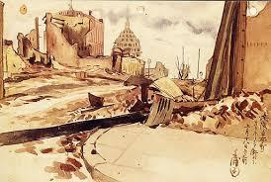
View of Burnt Out Japantown from California Street, Chiura Obata, 1906, Photo Credit PBS.org
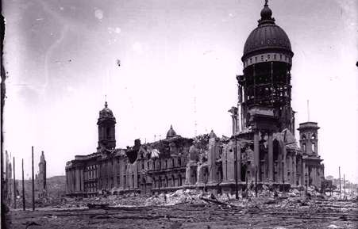
San Francisco City Hall after the 1906 Earthquake. Photography Curtsey of Steinbrugge Collection of the UC Berkeley Earthquake Engineering Research Center

Student Outcome : Students will explore primary documents to understand the severity of the 1906 SF Earthquake.

Common Core Standards
HSS-3.3 Students draw from historical and community resources to organize the sequence of local historical events and describe how each period of settlement left its mark on the land.
ELA/Literacy
W.4.7 Conduct short research projects that build knowledge through investigation of different aspects of a topic.
W.4.8 Recall relevant information from experiences or gather relevant information from print and digital sources; take notes, paraphrase, and categorize information, and provide a list of sources.
W.4.9.a,b Draw evidence from literary or informational texts to support analysis, reflection, and research.
RI.5.8 Explain how an author uses reasons and evidence to support particular points in a text, identifying which reasons and evidence support which point(s).
RI.5.9 Integrate information from several texts on the same topic in order to write or speak about the subject knowledgeably.
Library
LIB.6.4.3 Appreciate and respond to creative expressions of information: a. Demonstrate a variety of methods to engage the audience when presenting information (e.g., voice modulation, gestures, questions). b. Appreciate a range of creative forms of expression (e.g., poetry, drama, film, literature, visual arts). c. Evaluate one’s own research process and that of others in a respectful, cooperative, and productive way.

Associated Standards:
ESS1.C The History of Planet Earth - Local, regional, and global patterns of rock formations reveal changes over time due to earth forces, such as earthquakes. The presence and location of certain fossil types indicate the order in which rock layers were formed.

The following lesson plan was written by By Doug DuBrin, an English and history teacher as well as an editor and writer for PBS. It has been modified to include Chiura Obata’s artwork and biography in honor of APA Heritage Month. Orginial Lesson plan can be accessed here https://www.pbs.org/newshour/extra/lessons-plans/using-primary-documents-the-1906-san-francisco-earthquake/

Materials
Web Access
Primary Source Documents from http://www.sfmuseum.org/1906/ew.html -
Alternative Primary Source Documents
https://www.archives.gov/exhibits/sf-earthquake-and-fire/earthquake-fire.html Background articles
http://www.pbs.org/wgbh/amex/ansel/peopleevents/e_earthquake.html
http://quake.wr.usgs.gov/info/1906/
http://www.pbs.org/wnet/savageearth/earthquakes/
Background
Shortly after Chiura Obata immigrated to California, the 1906 Earthquake occurred. This natural disaster upended life in the Bay Area. Obata created artworks of the mayhem and destruction the earthquake caused.

“The 100th anniversary of the 1906 San Francisco earthquake and fire is April 18[, 2006]. The quake and the resulting fires were one of the most devastating natural disasters in United States history. Recent estimates place the death toll from the quake at close to 3,000, far more than the original tally of around 300. The physical devastation to the city itself was immeasurable, in great part due to the lack of structural reinforcements that we take for granted today. Yet, like most events of sweeping adversity (such as Hurricane Katrina or the terrorist attacks of Sept. 11, 2001), the people of San Francisco galvanized support for each other and from the outside and found ways to rebuild one of the country’s most beloved cities.”
Source : https://www.pbs.org/newshour/extra/lessons-plans/using-primary-documents-the-1906-san-francisco-earthquake/

Procedure
- Introduce the 1906 earthquake by sharing the above background information and showing Obata’s rendering of Japantown, along with the image of SF City Building
  - (Optional) Use the following resource to study the science of Earthquakes prior to this lesson https://www.calacademy.org/educators/teacher-guide-earthquakes
- Provide definitions for students of primary and secondary source documents. Explain that students will be examining primary source documents.
  - “Primary Source - provide raw information and first-hand evidence. Examples include interview transcripts, statistical data, and works of art. A primary source gives you direct access to the subject of your research.
  - Secondary Source - provide second-hand information and commentary from other researchers. Examples include journal articles, reviews, and academic books. A secondary source describes, interprets, or synthesizes primary sources.
Primary sources are more credible as evidence, but good research uses both primary and secondary sources.”
Source - https://www.scribbr.com/citing-sources/primary-and-secondary-sources/
- In order to gain a thorough understanding of the scope and impact of the disaster, have the students prior to the lesson carefully read the background articles provided above.
- Copy and randomly distribute to each member of the class a different firsthand account (there are 32 provided in the sfmuseum.org link above).
- Divide the class into groups of 3-4 students.
- Have each student read an account out loud to the other group members, while attempting to capture the mood and tone of the piece as it was written. For example, if the narrative is describing the horrible destruction of the quake and resulting fire, insist that the tone of the reading reflects it (i.e., the student should not be laughing while reading, but rather projecting a somber mood).
- Once each student has completed reading the narratives aloud, have the groups critically examine the texts by answering the following:
- What commonalities did you find in the content of the narratives? In other words, what are the shared memories of the experience?
  - Why might certain memories stand out more than others? What might cause a person to vividly remember the color of a lamp shattered by the quake when he/she would not ordinarily recall such a detail?
  - How might you identify the mood of the narratives? Are they all necessarily dark?
  - Could there be a sense of relief due to the simple fact of having survived? When recounting separate parts of the disaster, does the mood change within the individual narrative itself? If so, why might that be?
- Reconvene as a class to discuss the overall role and value of first hand historical accounts. To guide the discussion, you may wish to ask the following:
  - In what ways do personal narratives enrich our study of history? What do they provide that objective, analytical accounts of historical events do not?
  - In what ways are personal narratives limiting in their view of history? What do they lack as far as enriching our understanding of historical events?
  - How trustworthy are the firsthand accounts of historical events? What individual biases or external influences could get in the way of “truthful” reporting?
  - How does the age, gender or social status of the eyewitness influence the way in which he/she views the disaster?
  - Does the media today rely on firsthand accounts of events to report the news? Are reporters themselves discouraged from expressing their own opinions? In what ways does the news coverage of major events differ between television reporting and print media?

Extension Activity I: Analyzing other primary documents
For a follow-up activity, the procedures above can be applied to the study of firsthand accounts of other seminal events (besides the 1906 San Francisco earthquake) in American history. Included below are useful links to various other primary-document resources:
http://www.archives.gov/research/arc/
http://memory.loc.gov/ammem/index.html
http://historymatters.gmu.edu/browse/manypasts/
http://valley.vcdh.virginia.edu/
http://docsouth.unc.edu/fpn/

Works Cited
Durbin, Doug. “Using Primary Documents: The 1906 San Francisco Earthquake,” PBS News Hour Extra, 13, March 2006.
https://www.pbs.org/newshour/extra/lessons-plans/using-primary-documents-the-1906-san-francisco-earthquake/

Lesson 5 : Japanese Incarceration Experience and Political Art (grades 6-12)
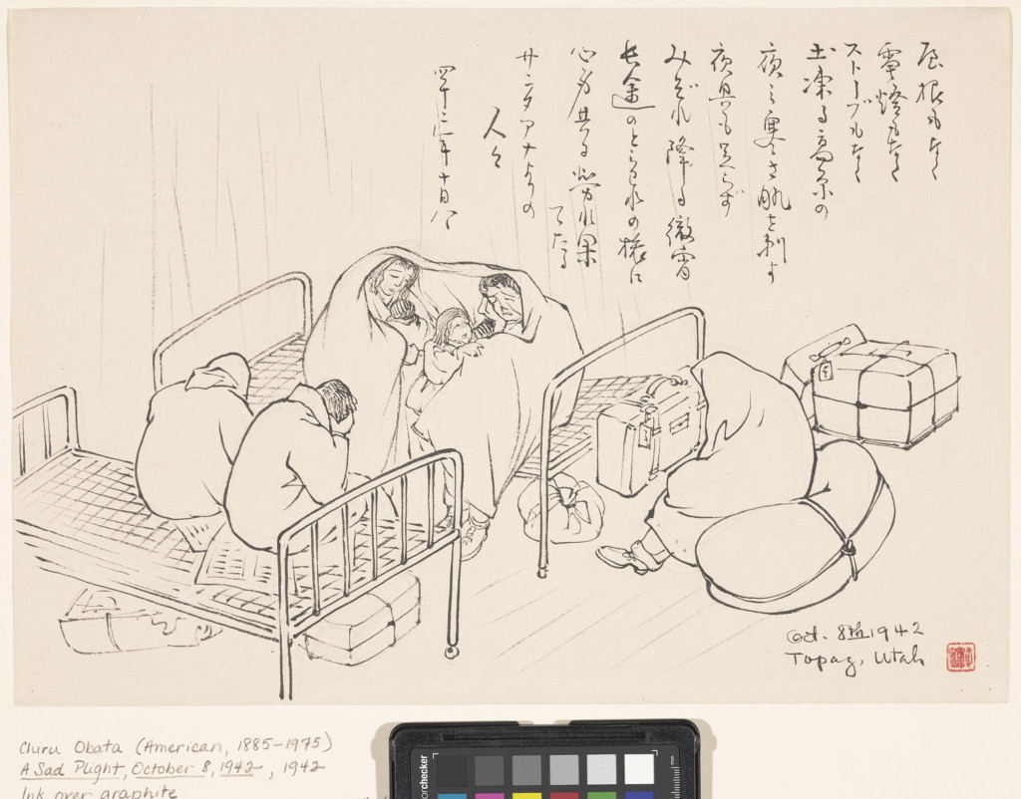
A Sad Plight, Chiura Obata (American, b. Japan, 1885–1975), October 8, 1942, Fine Arts Museums of San Francisco, Museum purchase, gift of the Graphic Arts Council, 2001.28.3

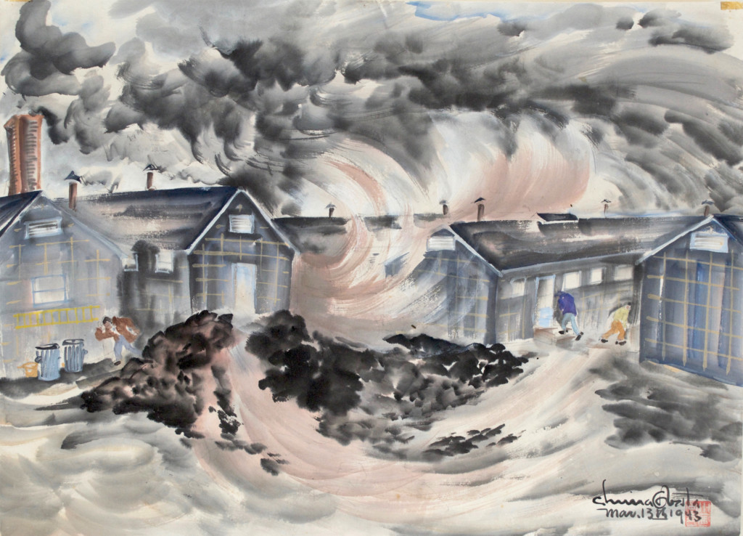
Dust Storm, Topaz, Chiura Obata (American, b. Japan, 1885–1975), March 13, 1943, private collection https://www.theutahreview.com/umfas-chiura-obata-american-modern-exhibition-artistic-meta-narrative-immigrants-faith-american-experiment/
Student Outcome : Students will explore Chiura Obata’s artwork as an introduction to political art during the WWII era. They will further consider the experiences of Japanese Americans during incaceration, before creating their own political art.

Grade levels : 6-12

Duration : 1 -2 weeks

Common Core Content Standards:
SL.8.5 Integrate multimedia and visual displays into presentations to clarify information, strengthen claims and evidence, and add interest.

Visual Arts
6.VA:Pr6 Objects, artifacts, and artworks collected, preserved, or presented either by artists, museums, or other venues communicate meaning and a record of social, cultural, and political experiences resulting in the cultivating of appreciation and understanding.

Media Arts
6.MA:Cr3 Experiment with multiple approaches to produce content and components for determined purpose and meaning in media arts productions, utilizing a range of associated aesthetic principles, such as point of view and perspective.
Appraise how elements and components can be altered for intentional effects and audience, and refine media artworks to reflect purpose and audience.
6.MA:Cn10 Access, evaluate, and use internal and external resources, such as knowledge, interests, and research, to create media artworks.
Explain and show how media artworks form new meanings, situations, and cultural experiences, such as historical events.
6.MA:Cn11 Discover and share ideas for media artworks using play and/or experimentation.
Research and show how media artworks and ideas relate to personal life, and social, community, and cultural situations, such as personal identity, history, and entertainment.
b. Analyze and interact appropriately with media arts tools and environments, considering copyright, ethics, media literacy and social media.

History and Social Science
HSS-10.8 Students analyze the causes and consequences of World War II.
HSS-11.7 Students analyze America’s participation in World War II.
HSS 11.7.5 Discuss the constitutional issues and impact of events on the U.S. home front,
including the internment of Japanese Americans (e.g., Fred Korematsu v. United States of
America) and the restrictions on German and Italian resident aliens; the response of the
administration to Hitler’s atrocities against Jews and other groups; the roles of women in military
production; and the roles and growing political demands of African Americans.
The following lesson plan has been adapted from Teaching Tolerance, and expanded to include ready made political art examples by Asian American Artists, like Chiura Obata, in honor of APA Heritage Month The original lesson can be found here : https://www.tolerance.org/classroom-resources/student-tasks/do-something/consuming-and-creating-political-art

Materials
(Optional) Topaz Moon: Chiura Obata's Art of the Internment.
Powerpoint - Political Art and the Japanese Internment Experience
General Art Supplies
Consuming & Creating Political Art Rubric
Do Something Student Planning Guide

Quotes providing Background info
Executive Order 9066
In February 1942, President Roosevelt signed Executive Order 9066, enforcing the “exclusion of Japanese Americans from the West Coast as a ‘military necessity’” and in March, the government enforced an 8p.m. curfew and a five-mile travel limit upon Japanese Americans (Hill 13). Obata and his family had to register and be fingerprinted as enemy aliens, and the mass-removal of California Japanese Americans had begun by mid-March. The Obatas were now aware of their pending evacuation from Berkeley, and began preparing for departure.
https://www.sullivangoss.com/artists/chiura-obata-1885-1975

“Executive Order 9066, authoriz[ed] the Secretary of War to “prescribe military areas . . . from which any or all persons may be excluded” and to “provide for residents of any such area who are excluded therefrom, such transportation, food, shelter, and other accommodations as may be necessary . . .” On March 2, Washington, Oregon, California, and Arizona were divided into two such military areas. Within a few months, Japanese American immigrants living on the west coast and their American-born children—citizens of the United States—had been removed from their homes and relocated to internment centers, known informally as “camps.” They lost their homes, their businesses, their pets, their friends, and most of their belongings. (Burton 30–33; Shumaker).
http://www.pbs.org/nationalparks/media/pdfs/untold_stories_manzanar.pdf

“Life for Obata, an art instructor at the University of California in Berkeley, was upended by the attack on Pearl Harbor and the government’s reaction in Executive Order 9066, which sent thousands of Americans of Japanese descent into internment camps. ‘His response was to keep making art,’ said Gretchen Dietrich, UMFA’s executive director.
The Obatas were moved first to the Tanforan Assembly Center, a converted racetrack in California, and later to Topaz. At both locations, Chiura Obata organized art schools. The Topaz Art School had 16 instructors, teaching some 600 students.

He created watercolors of beautiful Utah skies above what was essentially a prison camp. And he drew in ink — or scratched into the paper with dry pens when ink ran out — dozens of sketches presenting an almost photojournalistic look at day-to-day life in the camps.
The images from his internment period ‘are very short, agitated, emotional, unsettled,’ Wang said. “If you think about his physical being at the time, sitting on the train, on the bus, while still painting, which is a remarkable thing — that reflects his experience.”
The Obatas left Topaz in the spring of 1943 to live in the St. Louis area with their oldest son, Gyo, who was studying architecture at Washington University.”

Source : Means, Sean P. “Chiura Obata, who painted natural wonders and hardships of Japanese-Americans at Topaz, gets major exhibition at Utah Museum of Fine Arts,” The Salt Lake Tribune. 25, May 2018 https://www.sltrib.com/artsliving/arts/2018/05/25/chiura-obata-who-painted-natural-wonders-and-hardships-of-japanese-americans-at-topaz-gets-major-exhibition-at-utah-museum-of-fine-arts/

Procedure
- Determine whether students will work in groups or individually.
- Introduce students to political art. Show a wide variety of examples connected to themes in the central text you have been studying.
  - Explicitly teach the vocabulary associated with political art such as “idiom,” “satire,” “context clues,” “ irony,” “caricature,” etc.
  - Introduce Obata’s experience by showing his Artwork found in the Teacher Powerpoint : Political Art and the Japanese Internment Experience
- Consider using the art powerpoint provided in conjunction with this NY Times lesson plan on primary resources. Included are videos, primary sources, and photographs to humanize and investigate the Japanese American Experience.
“Teaching Japanese-American Internment Using Primary Resources, Rarely Seen Photos of Japanese Internment.” https://www.nytimes.com/2017/12/07/learning/lesson-plans/teaching-japanese-american-internment-using-primary-resources.html
- Provide students with a work schedule and due dates for their own political art piece.. Use the Consuming & Creating Political Art Rubric to define expectations and project components and to clarify how you will assess student work.
- Introduce students to the Do Something Student Planning Guide. Students can use the guide to decide what kind of work they want to produce, their message and what medium they will use.
- Provide ample time for students to create and revise their artwork and for peer and instructor feedback.
- Facilitate conversations between students and school leaders regarding permission and parameters for displaying art work.
- Find an appropriate location to display student work. Discuss how the context and location of art can affect its impact.
  - Options might include bulletin boards, hallway wall space, or common areas such as the cafeteria, gym or auditorium.
- Take photographs to memorialize and celebrate student’s work.

Conclusion
- Use journal writing or Talking Circles to facilitate student reflection on their individual art pieces. Some suggested reflection questions include:
  - What was your favorite piece of political art? What were its strengths? Why was it effective?
  - Discuss the effectiveness of using political art for social justice change.
  - What did you learn from this experience? What about the process stands out for you?
Extensions
- Use the teacher packet : Incarceration-through-Comics-and-Graphic-Novels, to research political cartoons before having students create their own.

Resources
Image credit - https://www.brainpickings.org/2018/03/23/chiura-obata-yosemite/

Lesson 2
Popova, Marina, “Chiura Obata’s Stunning Paintings of Yosemite,” Brainpickings,
https://www.brainpickings.org/2018/03/23/chiura-obata-yosemite/

Lesson 3
Siber, Kate, “Wood Blocks & Water Colors,” National Parks Conservation Association, Summer 2013, https://www.npca.org/articles/1041-wood-blocks-water-colors

Shumaker, Susan, “Untold Stories from America’s National Parks - Chiura Obata,” PBS, National Parks, America’s Best Idea.

Lesson 4
Durbin, Doug, “Using Primary Documents: The 1906 San Francisco Earthquake,” PBS News Hour Extra, 13, March 2006
https://www.pbs.org/newshour/extra/lessons-plans/using-primary-documents-the-1906-san-francisco-earthquake/

Further Resources
Teacher Guide: Earthquakes, Cal Academy
https://www.calacademy.org/educators/teacher-guide-earthquakes

Lesson 5
Consuming and Creating Political Art, Teaching Tolerance
https://www.tolerance.org/classroom-resources/student-tasks/do-something/consuming-and-creating-political-art

Backman, Marjorie and Gonchar, Michael “Teaching Japanese-American Internment Using Primary Resources, Rarely Seen Photos of Japanese Internment.” New York Times, 7 Dec 2017
https://www.nytimes.com/2017/12/07/learning/lesson-plans/teaching-japanese-american-internment-using-primary-resources.html

Means, Sean P. “Chiura Obata, who painted natural wonders and hardships of
Japanese-Americans at Topaz, gets a major exhibition at Utah Museum of Fine Arts,” The Salt Lake Tribune. 25, May 2018 https://www.sltrib.com/artsliving/arts/2018/05/25/chiura-obata-who-painted-natural-wonders-and-hardships-of-japanese-americans-at-topaz-gets-major-exhibition-at-utah-museum-of-fine-arts/

Further Resources
Chiura Obata papers, circa 1891-2000, 1942-1945 “The papers of Japanese American artist Chiura Obata measure 1.4 linear feet and date from 1885-1975. Included are biographical material relating to Obata's internment; administrative files regarding the establishment and management of art schools at Tanforan and Topaz detention sites; writings by Obata; teaching files from the University of California, Berkeley; project and exhibition files; personal and professional correspondence; photographs; artwork including sketchbooks and loose drawings by Obata and printed material.” https://www.aaa.si.edu/collections/chiura-obata-papers-17607

Kuramitsu, Kristine C. “Internment and Identity in Japanese American Art.” American Quarterly. Vol. 47, No. 4 (Dec., 1995). 619-658. https://www.jstor.org/stable/2713369?seq=1

Sue Kunitomi Embrey and Manzanar National Historic Site, The National Parks: America’s Best Idea, Untold Stories Discussion Guide, PBS.org
http://www.pbs.org/nationalparks/media/pdfs/untold_stories_manzanar.pdf

Teaching Japanese American Incarceration Through Comics & Graphic Novels, Smithsonian,
National Museum of American History, Incarceration Through Comics and Graphic Novels

