ARTIFACT ANALYSIS ACTIVITY

Inquiry Question: What might have been the appeal of Japanese swords for consumers in China and other countries? (Why might people want to buy these swords?)
Source: Unknown craftsman, Short sword (wakizashi) and Long sword (katana) with blade mountings, Japan, Muromachi period (1333–1573).
Materials: Forged and tempered steel, sharkskin, black lacquer, gold on bronze.
Context: We are examining images of two Japanese samurai swords, sheathed and unsheathed. We are considering them not as weapons of war but as trade goods and works of art.
Inquiry Question: What might have been the appeal of Japanese swords for consumers in China and other countries?
Artifact:
Creator:
Possible Users:
Place and Time:
Observe the swords carefully. What do you see? Can you make any connections to what you learned in your Expert Groups? List or sketch specific details.
Considering our research in our Expert Groups, why would Japanese swords be seen as valuable goods for trade? (Include at least one insight from each expert in your Jigsaw Group).

Using Artifacts to Understand the Past - Japanese Swords
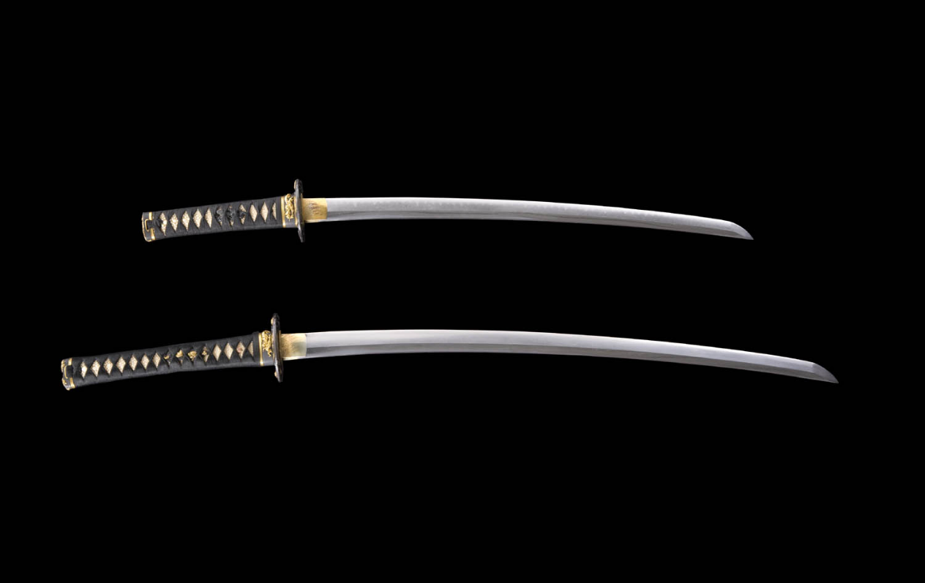
Unsheathed Sword: Unknown craftsman, Short sword (wakizashi) and Long sword (katana) with blade mountings, Japan, Muromachi period (1333–1573).
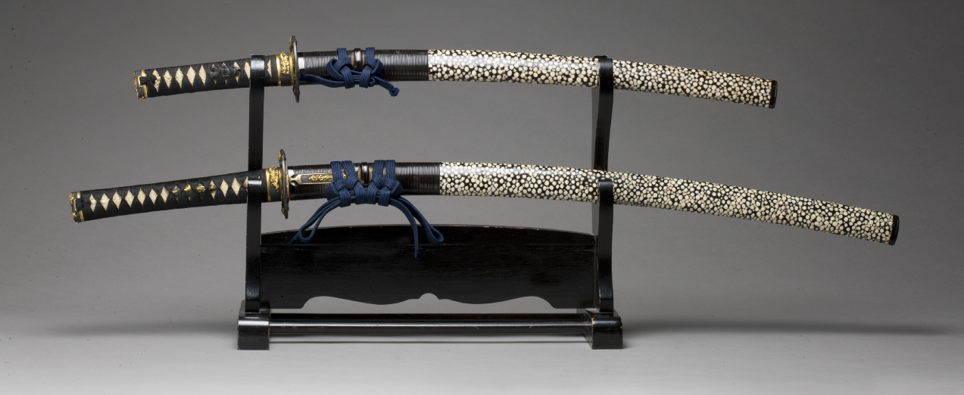
Sheathed Sword: Unknown craftsman, Short sword (wakizashi) and Long sword (katana) with blade mountings, Japan, Muromachi period (1333–1573), forged and tempered steel, sharkskin, black lacquer, gold on bronze. From the Avery Brundage Collection, Asian Art Museum of San Francisco.

Click on website image for close-Up view: http://asianart.emuseum.com/view/objects/asitem/items$0040:7760

Directions: In your Jigsaw Groups, share the information you learned in your Expert Groups to answer the following questions together. Wherever possible, share tables, images, or examples to help support your answers.
Comprehension Questions

1. Why did Japan trade with the mainland?
2. Who conducted trade between Japan and the mainland?
3. What goods were traded between Japan and China?

4. Based on data in the chart, what were the most valuable trade goods for the Japanese?

Interpretive Questions

5. What can the prices of Japanese swords tell us about the demand for swords?
6. What values or ideals might have traveled with the swords that were traded?
7. What might the value of Japanese exports mean for Japanese access to imports?

